|  |
| --- |
| Web Master .inc |
| SLOT MACHINE |
| Document |
| Version #2.0  All work Copyright © 2016 by WebMaster .Inc.  All rights reserved. |
| Duc Minh Tran - 300771859 |
|  |

|  |
| --- |
| Feb 19th 2016 |

Table of Contents

1. Game Description 4

2. Game Play Mechanics 4

3. Controls 4

4. Interface Sketch 5

5. Screen Descriptions 6

6. Scoring 7

7. Art/ Multimedia Index 8

8. Cheat mode 10

Version History

* Version 1.0 Initial commit
* Version 1.1 Main Core Finished
* Version 1.2 ReadMe updated
* Version 1.3 working on new feature
* Version 1.4 Add shuffling animation
* Version 1.5 Adding lose alert box
* Version 1.6 Preload scene Fixed
* Version 1.7 Loading Issues Fixed
* Version 1.8 Game Completed!
* Version 2.0 Internal Document completed

# Game Description

This is a simulated Slot Machine game made by me. The game has almost all the functionality of a real slot machine. I try to keep it simple to make it easier to understand.

To play my game, player will have to put an amount of money to bet if the machine outputs a valid result. There are options to bet $1, $10, $50, $100, $500. Player can still modify the bet through + and – button, clear the bet with a simple button. When players are satisfied with the bet. They can press the spin button. The machine will operate and give results, it also determines if you win or lose, the amount of money you earn or lose. All the amount of money, bet, jackpot are shown on my GUI. When you run out of money, you will be blocked and asked to play again. The play again and quit game option are always available throughout the gameplay.

# Game Play Mechanics

When player press the Spin button, the machine will check if the bet is valid or not. Player will be prompted when bet money is 0, amount of bet exceed current amount of money or there is no money left. Once the spin button pressed, the logic will start the animation on Update () function. I tried to make the images shuffle in 5 seconds, before showing the final result. The result is depend on random variables, and they will be determined randomly. When final result is ready, the machine will be updating all the label corresponding to it. You can be losing money, gaining money, or even having a small chance to win the $5000 Jackpot.

# Controls

I provided players with a simplified control pad. Players will first have to press play button in order to get into the play scene. In there, they can choose the amount of money to bet with +$5, +$10, +$50, +$100, +$500 buttons. They can also increase or decrease the bet through + and – buttons respectively. The reset and quit game buttons are always works throughout the entire game. After getting the result from spinning, players will also receive prompt messages with buttons without functions attached to it.

# Interface Sketch

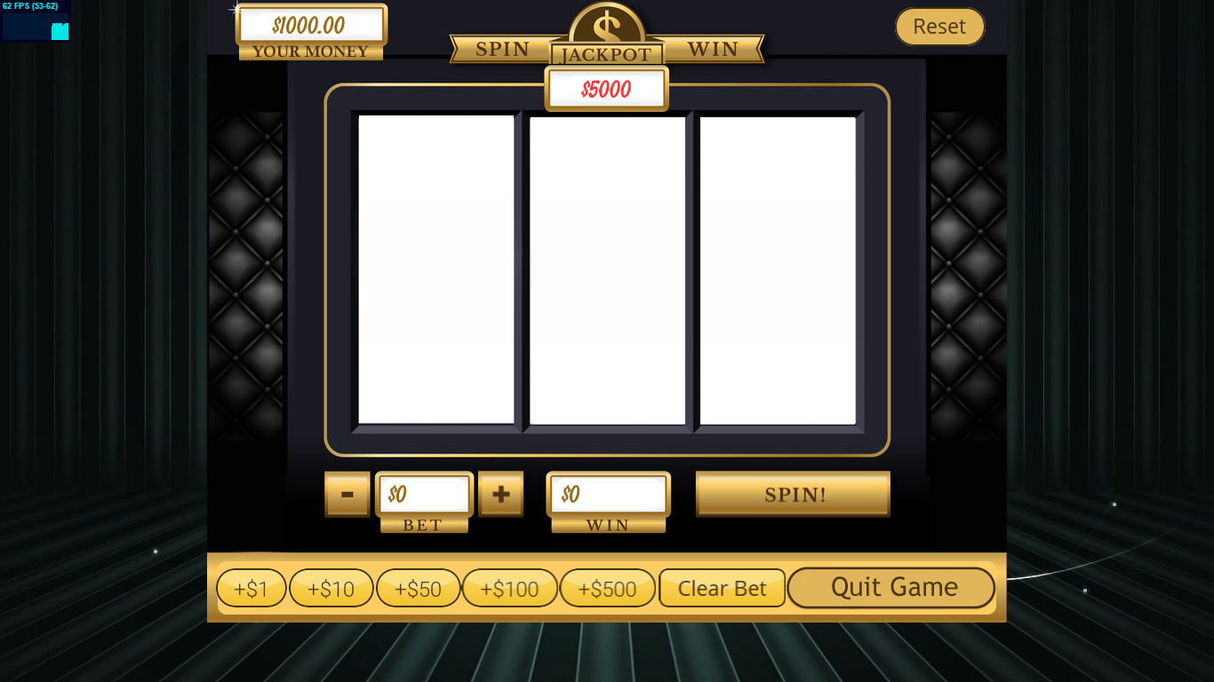

# Screen Descriptions

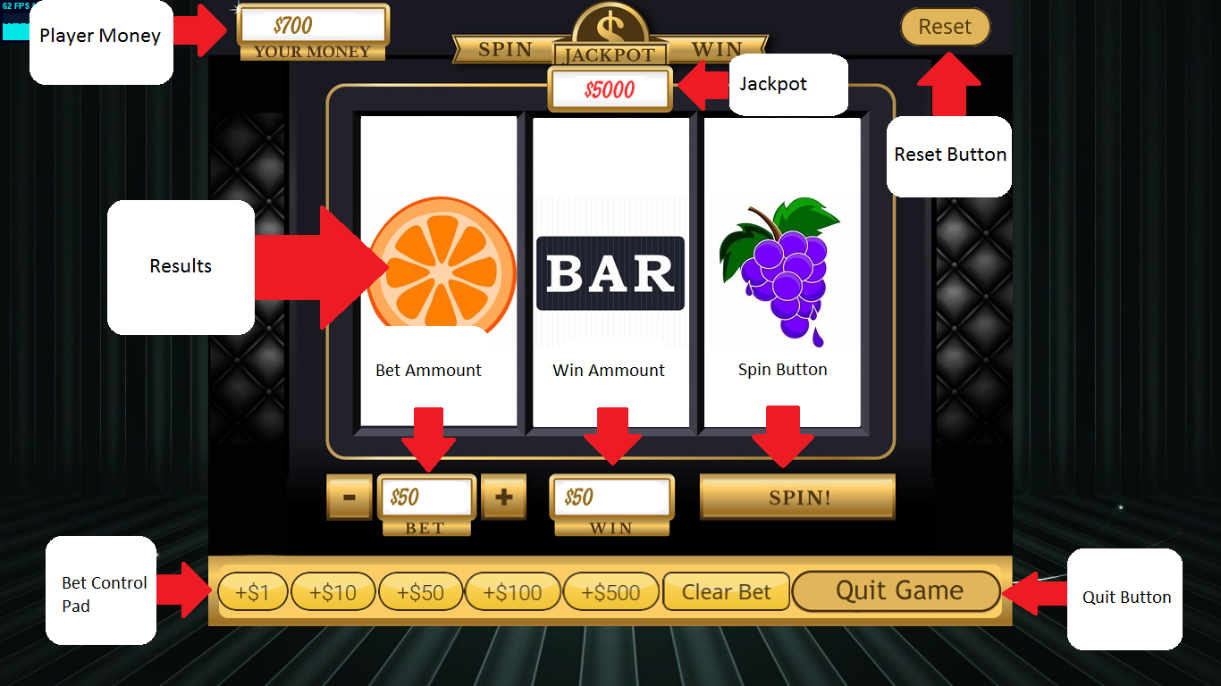

# Scoring

After spinning, player will only be wining if the result does not contain a “Blank”. If result does contain a “Blank”, player will lose the bet amount.

All other conditions will be listed on the table below.

|  |  |
| --- | --- |
| Conditions | Outcomes |
| grapes = 3 | Player Bet * 10 |
| bananas = 3 | Player Bet * 20 |
| oranges = 3 | Player Bet * 30 |
| cherries = 3 | Player Bet * 40 |
| bars = 3 | Player Bet * 50 |
| bells = 3 | Player Bet * 75 |
| sevens = 3 | Player Bet * 100 |
| grapes = 2 | Player Bet * 2 |
| bananas = 2 | Player Bet * 2 |
| oranges = 2 | Player Bet * 3 |
| cherries = 2 | Player Bet * 4 |
| bars = 2 | Player Bet * 5 |
| bells = 2 | Player Bet * 10 |
| sevens = 2 | Player Bet * 20 |
| sevens = 1 | Player Bet * 5 |
| Others Conditions | Player Bet * 1 |

# Art/ Multimedia Index

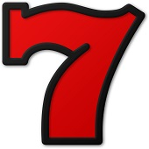

My slot machine preloaded these following assets:

addBet.jpg

BackButton.png

banana.jpg

bar.jpg

bell.jpg

bet1.png

bet10.png

bet100.png

bet50.png

bet500.png

blank.jpg

cherries.jpg

ClearBetButton.png

favicon.ico

GameOver-fixed.jpg

GameOver.jpg

GameOver.psd

grapes.jpg

loading.jpg

loadingBG-fixed.jpg

loadingBG.jpg

loadingBG.psd

mainBG.jpg

menuBG-fixed.jpg

menuBG.jpg

menuBG.psd

minusBet.jpg

NextButton.png

orange.jpg

preloader.png

QuitButton.png

ResetButton.png

seven.jpg

slotmachine-fixed.png

slotmachine.jpg

slotmachine.psd

spinBtn.jpg

StartButton.png

StartOverButton.png

Feeling Happy ' Stay See Summer Mix 2015.mp3

InsertCoins.mp3

jackpot.mp3

lose.mp3

normalWin.mp3

spin.mp3

# Cheat mode

Hot Key Ctrl+J will enable cheat mode, there will be no losing. Players will get a jackpot every time they spin the reels